**Homework 3 – Data Format**

**Importing data in Avro format:**

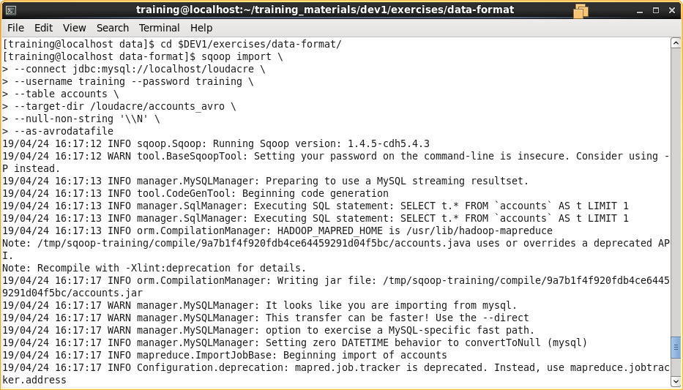

Viewing Avro imported file in Hue Browser:

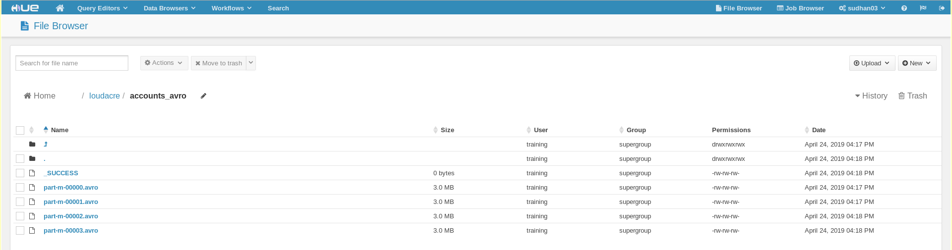

Copied the “sqoop_import_accounts.avsc” file from local to loudacre HDFS folder.

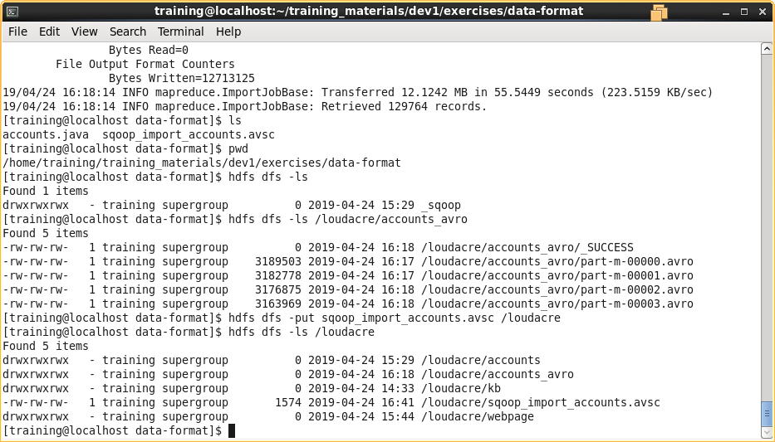

In Impala or Hive, create a table using this schema:

Confirm correct creation of the table by issuing a query such as

